**Functional Requirement:**

1) Start the game

2) System should display a 3*3 board to user

3) Users can input either “X” OR “O”

4) The first user’s input is “X”

5) If user inputs “X”, next input will be “O” automatically and vice versa.

6) Users can enter their name

7) Reset the game

**Non-functional Requirement:**

1. Learnability

**Use case diagram:**

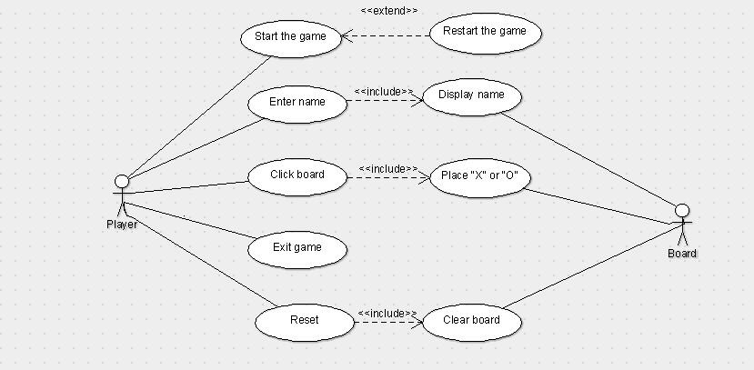

**Use case scenarios:**

|  |  |
| --- | --- |
| Use Case ID | UC1 |
| Use Case Name | Start a game |
| Primary Actor | Tic Tac Toe Player |
| Secondary Actor | Game Board |
| Pre Conditions | Game should be downloaded in the system |
| Success Guarantee (Postconditions) | Player should be able to start the game |
| Main Success Scenario | 1. The user click on start button  2. System will start the game |
| Extensions (Alternative Scenario) | 2a. At any point of time if there is an error displayed, then user should be able to change the parameters. |

|  |  |
| --- | --- |
| Use Case ID | UC2 |
| Use Case Name | Place “X” or “O” |
| Primary Actor | Tic Tac Toe Player |
| Secondary actor | Game Board |
| Pre Conditions | There should be available space for user to click |
| Success Guarantee (Postconditions) | “X” or “O” is displayed to user |
| Main Success Scenario | 1. The user starts the game  2. The game board is displayed on the screen  3. The user clicks on one of the 9 spaces on the board  4. The user can input either “X” or “O” |
| Extensions (Alternative Scenario) | 4a. At any point of time if there is an error displayed, then user should be able to change the parameters. |

|  |  |
| --- | --- |
| Use Case ID | UC3 |
| Use Case Name | Reset the game |
| Primary Actor | Tic Tac Toe Player |
| Secondary actor | Game Board |
| Pre Conditions | 1. Game should be downloaded in the system 2. Game board should be displayed to the user |
| Success Guarantee (Postconditions) | Clear game board should be displayed to the player |
| Main Success Scenario | 1. The user click on start button  2. System will start the game and game board is displayed  3. |
| Extensions (Alternative Scenario) | 2a. At any point of time if there is an error displayed, then user should be able to change the parameters. |